
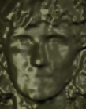


Database
3D sensor
3D Image
Shape
Texture
Facial Landmark Extraction
Attributed Relational Graph
(Shape and Texture)
Matching Scenarios:
2-D – 2-D
3-D – 3-D
Multimodal (2-D + 3-D)

Match

